=== RUNNING ENHANCED OUTLIER ANALYSIS ===
Enhanced features shape: (22,)
Found 200 outliers (5.0%)
Outlier threshold: 0.2009

=== OUTLIER STATISTICS ===
Mean residual (normal): 0.0579
Mean residual (outliers): 0.2810
Max residual: 0.5972

=== FEATURE ANALYSIS ===
Features significantly different in outliers (p < 0.05):
root_cpd_1: p = 0.0000
root_cpd_0: p = 0.0000

=== PROBABILITY RANGE ANALYSIS ===
Outliers in extreme low range (0-0.1): 30
Outliers in extreme high range (0.9-1.0): 1
Outliers in mid range (0.1-0.9): 169=== SPECIFIC OUTLIER ANALYSIS ===

2 Worst OVER-predictions:
Sample 49: True=0.253, Pred=0.741, Error=0.488
Evidence nodes: 0, Num parents: 0
In/Out degree: 0/2
Betweenness: 0.000, PageRank: 0.014
Sample 89: True=0.128, Pred=0.725, Error=0.597
Evidence nodes: 0, Num parents: 0
In/Out degree: 0/2
Betweenness: 0.000, PageRank: 0.014

2 Worst UNDER-predictions:
Sample 142: True=0.538, Pred=0.291, Error=-0.247
Evidence nodes: 0, Num parents: 0
In/Out degree: 0/2
Betweenness: 0.000, PageRank: 0.014
Sample 117: True=0.616, Pred=0.331, Error=-0.285
Evidence nodes: 0, Num parents: 0
In/Out degree: 0/2
Betweenness: 0.000, PageRank: 0.014
Accuracy: 0.9117
Underpredict Rate: 0.554
Average Underprediction Error: 0.0552
MAE: 0.0691
RMSE: 0.0957
Avg Time/Epoch: 0.67s
Total Time: 33.59s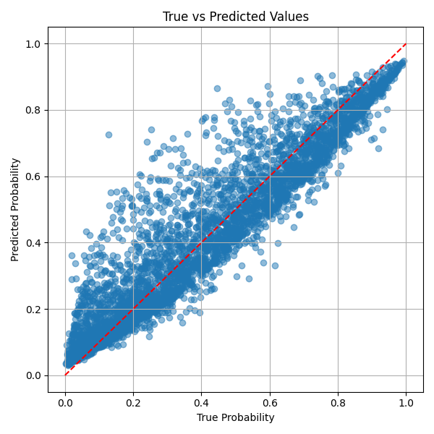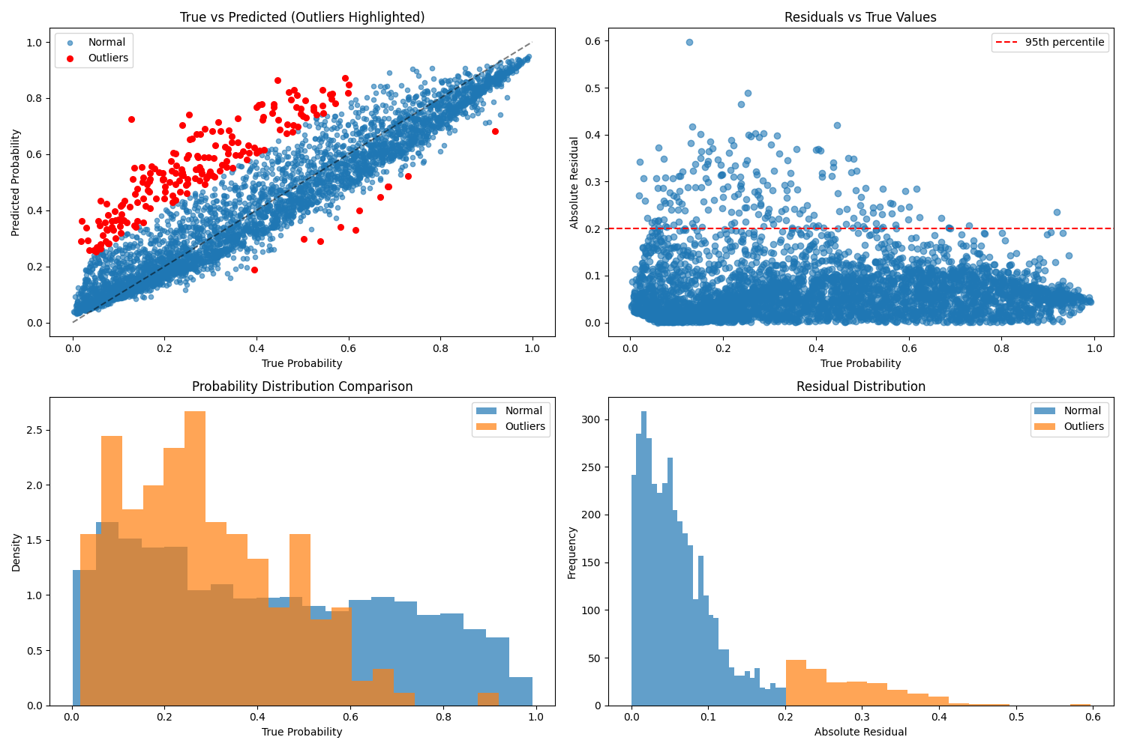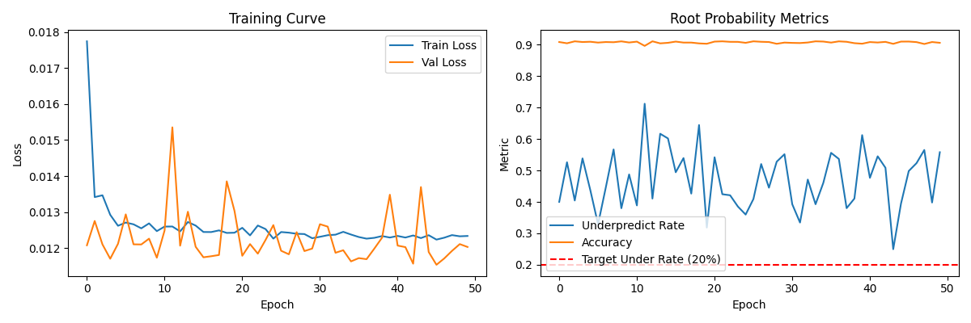
=== RUNNING ENHANCED OUTLIER ANALYSIS ===
Enhanced features shape: (22,)
Found 200 outliers (5.0%)
Outlier threshold: 0.2721

=== OUTLIER STATISTICS ===
Mean residual (normal): 0.0656
Mean residual (outliers): 0.3554
Max residual: 0.6870

=== FEATURE ANALYSIS ===
Features significantly different in outliers (p < 0.05):

=== PROBABILITY RANGE ANALYSIS ===
Outliers in extreme low range (0-0.1): 14
Outliers in extreme high range (0.9-1.0): 6
Outliers in mid range (0.1-0.9): 180

=== DATA QUALITY CHECKS ===
NaN values in features: 0
Inf values in features: 0
Number of feature names: 22
Number of features in data: 22
=== SPECIFIC OUTLIER ANALYSIS ===

2 Worst OVER-predictions:
Sample 146: True=0.128, Pred=0.702, Error=0.574
Evidence nodes: 0, Num parents: 0
In/Out degree: 0/2
Betweenness: 0.000, PageRank: 0.014
Sample 59: True=0.103, Pred=0.790, Error=0.687
Evidence nodes: 0, Num parents: 0
In/Out degree: 0/2
Betweenness: 0.000, PageRank: 0.014

2 Worst UNDER-predictions:
Sample 197: True=0.717, Pred=0.258, Error=-0.458
Evidence nodes: 0, Num parents: 0
In/Out degree: 0/2
Betweenness: 0.000, PageRank: 0.014
Sample 0: True=0.706, Pred=0.246, Error=-0.459
Evidence nodes: 0, Num parents: 0
In/Out degree: 0/2
Betweenness: 0.000, PageRank: 0.014
Accuracy: 0.9000
Underpredict Rate: 0.357
Average Underprediction Error: 0.0805
MAE: 0.0801
RMSE: 0.1187
Avg Time/Epoch: 0.68s
Total Time: 58.34s
